# Aim 3D: Voodoo

Inhoud

Aim 3D: Voodoo 1

**Game description** 2

**Game play** 2

Player 1 (Voodoo) 3

Player 2 (Master) 3

**Target market** 3

Pars Pro Toto: 3

**Art and Video** 4

**Production** 5

Planning Developers 6

6

Planning Artists 6

6

**Technical Specs** 7

Code versioning 7

Code Objects 7

**Game description**

**Game title:** Voodoo

**Platfromer:** PC

**Genre:** 3D Horror Co-Op

**Developpers:**

Daniel Brand

Pim Horeman

**Artists:**

Amber Kalverboer

Twan Bijpost

Amber Huiskes

**Game play**

The goal in Voodoo is to reach the exit of your own home, after an experiment gone wrong caused an explosion which left you paralyzed, and freed ghosts to wander your home freely.

In Voodoo, the game mechanics are divided between 2 players. One player moves and looks around but with an impaired vision. While the other player can look around, see ghosts and other dangers, and can use magic to move walls or other objects in the house.

### Player 1 (Voodoo)

1. Move
2. Look around freely, but with an impaired vision
3. See pickups

### Player 2 (Master)

1. Look around horizontal.
2. Controls the light, which if on will let player 1 see the same things as player 2
3. See dangers (Ghosts, Traps)
4. See hidden paths
5. See Manabalk

**Target market**

The target market for Voodoo are teens between 15/18 years old.

### Pars Pro Toto:

This is Bert van de Ven. He is sixteen years old and in his last year of high school. He lives in Amstelveen together with his older sister and younger brother (and their parents). In his spare time he prefers to play games and he is interested in an education in Game Art. At home he likes to play first person shooters, like Call of Duty but also RPG games, like The Witcher 3, although he also spends quite some time in MMORPGs where he can game with his friends and work together to achieve goals.

Ever since he played a game with an Oculus Rift, his interest in games that do things differently has grown even further, because he realized that there are way more possibilities to play a game than he first realized. That the game industry has a lot more to offer than the standard platforms, continues to interest him.

**Art and Video**

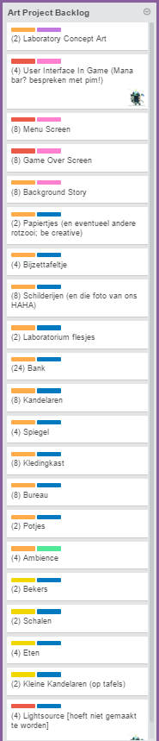

**Production**

### Planning Developers

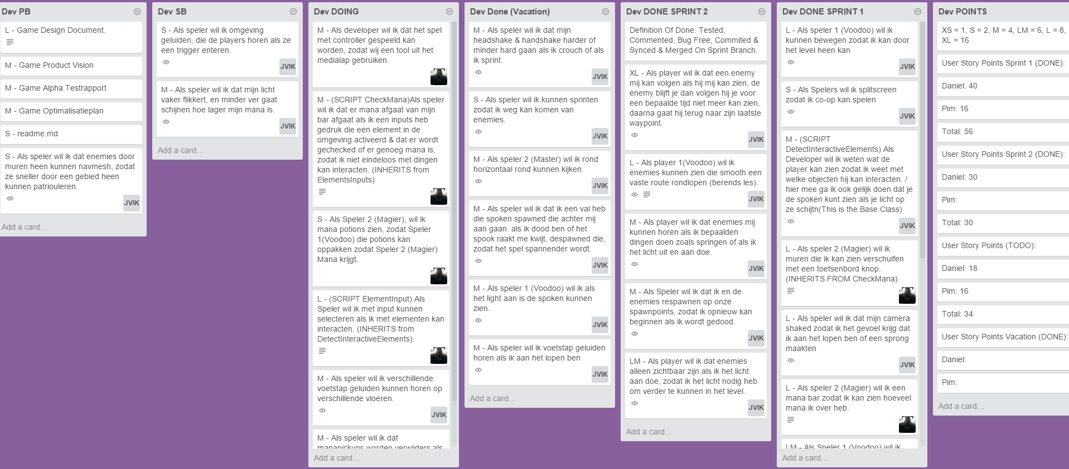

### Planning Artists

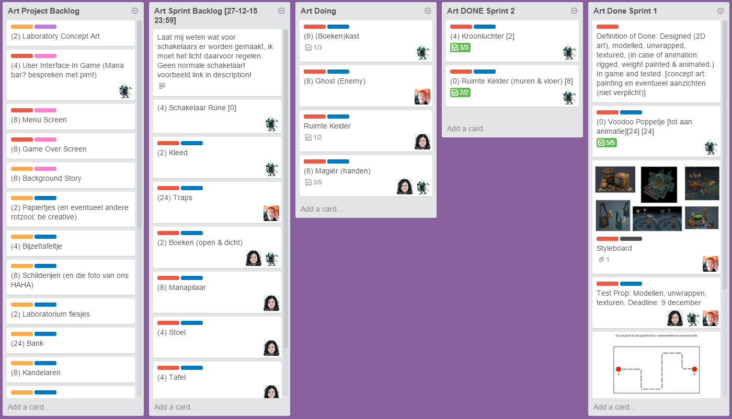

**Technical Specs**

### Code versioning

https://github.com/Pimmez/AIM3D

### Code Objects